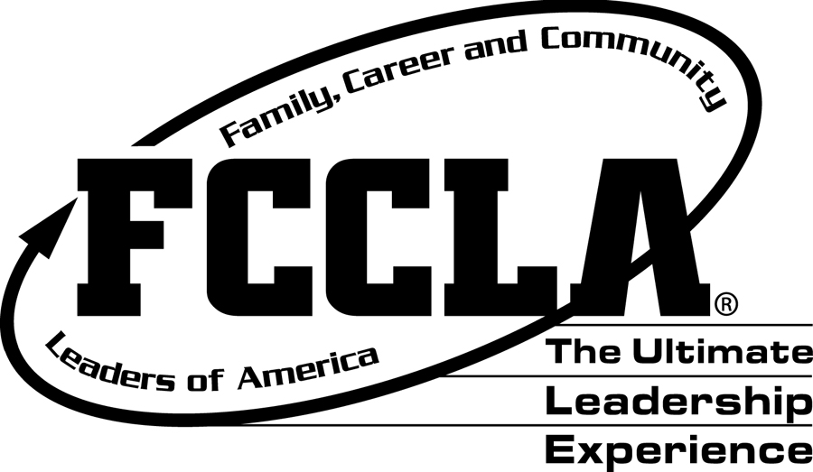
KANSAS FCCLA
ALUMNI & ASSOCIATES
SCHOLARSHIP APPLICATION DIRECTIONS

Please email a copy of your completed Scholarship Application to:
Shandi Andres at: sdandres@ksu.edu by February 20

ELIGIBILITY : To be eligible, an applicant must have:
- Been an active FCCLA member for three semesters
- Completed at least two semesters of Family and Consumer Sciences at the high school level
- An above-average scholastic record
- Participated in school and community activities
- Plan for a career in any field.

PROVISIONS FOR AWARDING SCHOLARSHIPS:
- The scholarship is available to FCCLA members and former members.
- It is available to prospective college freshman or upperclassmen who meet the above criteria.
- Scholarship recipients may reapply for scholarship.
- May attend any two or four-year college or university in Kansas.
- Five, $500 scholarships may be awarded.
- Scholarships will be paid directly to the institution after receiving verification of enrollment from the scholarship recipient.
- Applications must be sent to the State FCCLA Office.
- Recipients will be announced at the annual State Leadership Conference.

HIGH SCHOOL SENIORS should complete the entire application form and return it with a high school transcript with the counselor’s signature. On a separate paper, please list your FACS courses taken in high school and the length of time in which you took them. (One or two semesters)

COLLEGE STUDENTS applying for the first time or reapplying should complete the entire form, adding college information in items IV, V, VI, VII, VIII, and XV, and include a college transcript.

SCHOLARSHIP RECIPIENTS APPLYING FOR RENEWAL should complete I, IV, V, VI, VII, VIII, X, XI, XIII, and XV. List college information only and include college transcript.

KANSAS FCCLA
ALUMNI & ASSOCIATES
SCHOLARSHIP APPLICATION FORM

DO NOT ALTER THE FORMAT OF THIS APPLICATION AND
PLEASE TYPE EVERYTHING IN AN ARIAL 12-POINT FONT.

 | Date of Application:
 | Name of Applicant:
 | Applicant Address:
 | Parent’s Names:
 | Parent’s Address:
 | Total Semesters of FACS Courses Taken:
 | Years as an FCCLA Member:
II. | High School(s) Attended:
II. | High School(s) Address:
II. | Dates Attended:
II. | Graduation Date:
III. | Summarize your FCCLA Activities. List the offices you held.
IV. | Summarize your school activities other than FCCLA.

V. | Summarize your FACS activities and projects.
VI. | Summarize your community and state activities.
VII. | List high school or college scholastic honors. (Honorary Societies, etc.)
VIII. | List your work experience. Include your employer, the type of work, and your dates of employment.
IX. | What college or university in Kansas do you plan to attend?
X. | Itemize Financial Information for the coming year:
X. | Amount College will cost: | ---------------- $
X. | RESOURCES
X. | Assistance from Parents: | $
X. | Savings: | $
X. | Summer employment: | $
X. | Work in College: | $
X. | Scholarships or other: | $
X. | TOTAL RESOURCES | $
X. | Total Amount Needed: | $
XI. | Explain the following:
XI. | Why do you plan to continue your education?
XI. | What specific area will be your major?

 | What are your plans upon completing college?
XII. | Describe your family, number of members, occupations, etc.
XIII. | Include with your application form:
 | Statement from your advisor summarizing your FCCLA and FACS activities.
 | Statement of recommendation from School Administrator. (College Students include college advisor statement.)
 | High School Transcript (Must have a B average or above) If attending college, send college transcript only.
XIV. | Signature of Applicant | Date:

Please email a copy of your completed Scholarship Application, Advisor Statement, School Administrator Recommendation and Transcript to:
Shandi Andres at: sdandres@ksu.edu by February 20

Please send as 1 pdf if possible.

ALUMNI & ASSOCIATES SCHOLARSHIP APPLICATION SCORE CARD
TO BE COMPLETED BY THE EVALUATION COMMITTEE

NAME AND ADDRESS:______________________________________________________________________

CRITERIA | 10 | 9 | 8 | 7 | 6 | 5 | 4 | 3 | 2 | 1 | COMMENTS
Grades and HE/FACS Classes
FCCLA Activities & Offices
School Activities

HE/FACS Activities

Community and State Activities
Honors

Work Experience

Expenses Needed

Reasons for Continuing Education
Family Description

FCCLA Advisor Recommendation
Admin./College Advisor Recommendation
Career Plan

Financial Needs

Grammar/Spelling/ Neatness

Reapplying for scholarship: _____
Applying for community college: _____ Applying for four-year college or university:_____

COMMENTS:

