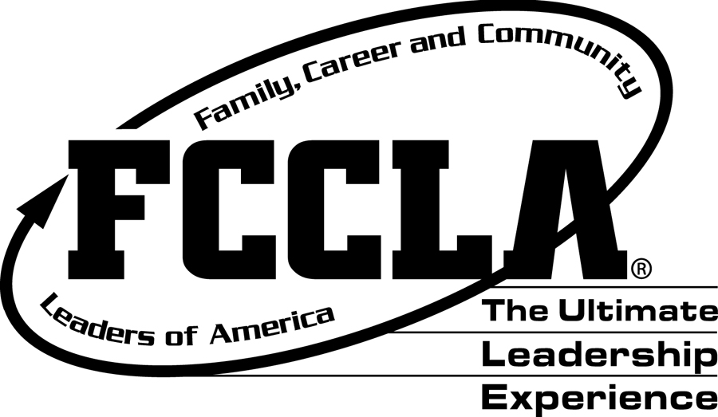
KANSAS FCCLA LEADERSHIP
SCHOLARSHIP APPLICATION DIRECTIONS
Please email a copy of your completed Scholarship Application to:
Shandi Andres at: sdandres@ksu.edu by February 20

ELIGIBILITY REQUIREMENTS:
The scholarship candidate:
- has been an active FCCLA member for three semesters
- has completed at least two semesters of Family and Consumer Sciences at the high school level
- has participated in school and community activities
- has a 3.0 GPA on a 4.0 scale
- is planning for a career of their choice
- if reapplying, must be a Kansas alumni and associates member

PROVISIONS FOR AWARDING SCHOLARSHIPS:
- The scholarship is available to graduating FCCLA members and Kansas alumni FCCLA members
- It is available to prospective college freshman or upper classmen who meet the above eligibility requirements.
- Scholarship recipients may reapply for this scholarship as long as they maintain an active Kansas FCCLA alumni membership.
- Scholarship recipient must attend a two or four-year college or university in Kansas.
- Up to seven scholarships of $500 each may be awarded each year.
- Applications must be sent to the Kansas FCCLA State Office
- Scholarships will be paid directly to the college or university after the Kansas FCCLA state office has received verification of enrollment
- Recipients will be announced at the annual State Leadership Conference.

HIGH SCHOOL SENIORS should complete the entire application form and return it with a high school transcript with the counselor’s signature. On a separate paper, please list your FACS courses taken in high school and the length of time in which you took them. (One or two semesters) Scan & Email directly to Shandi Andres sdandres@ksu.edu

COLLEGE STUDENTS applying for the first time or reapplying should complete the entire form, adding college information in items IV, V, VI, VII, VIII, and XV, and include a college transcript.

SCHOLARSHIP RECIPIENTS APPLYING FOR RENEWAL should complete I, IV, V, VI, VII, VIII, X, XI, XIII, and XV. List college information only and include college transcript.
KANSAS FCCLA
LEADERSHIP SCHOLARSHIP
APPLICATION FORM

DO NOT ALTER THE FORMAT OF THIS APPLICATION
AND PLEASE TYPE EVERYTHING IN AN ARIAL 12-POINT FONT.

I. | Date of Application:
I. | Name of Applicant:
I. | Applicant Address:
I. | Parent’s Names:
I. | Parent’s Address:
I. | Total Semesters of FACS Courses Taken:
I. | Years as an FCCLA Member:
I. | Type of Chapter: (Occupational or Comprehensive)
II. | High School(s) Attended:
II. | High School(s) Address:
II. | Dates Attended:
II. | Graduation Date:
III. | Summarize your FCCLA Activities. List the offices you held and/or committees you served on.
IV. | Summarize your school activities other than FCCLA.
V. | Summarize your FACS activities and projects.
VI. | Summarize your community and state activities.
VII. | List high school or college scholastic honors. (Honorary Societies, etc.)
VIII. | List your work experience. Include your employers, type of work, and your dates of employment.
IX. | What college or university in Kansas do you plan to attend?
X. | Summarize in a paragraph why you feel you deserve this scholarship.
XI. | Explain the following:
XI. | Why do you plan to continue your education?
XI. | What will be your major area of study?
XI. | What are your plans upon completing your education?
XI. | How do your future plans include FCCLA?
XII. | Describe the leadership role you assume in your family.
XIII. | Include the following with your application form:
XIII. | Statement of recommendation from your Chapter Advisor, School Administrator, or College Academic Advisor.
XIII. | High School Transcript (must have a 3.0 GPA or above) with counselor’s signature. If attending college, send college transcript only.
XIV. | Signature of Applicant |  |  |  |  |  | Date:

Please email a copy of your completed Scholarship Application, Transcript, and Statement of Recommendation to Shandi Andres at: sdandres@ksu.edu

Please send as 1 pdf if possible.

SCHOLARSHIP APPLICATION SCORE CARD
TO BE COMPLETED BY THE EVALUATION COMMITTEE

Name:________________________________________________
Address: ______________________________________________

CRITERIA | 5 | 4 | 3 | 2 | 1 | COMMENTS
FACS/OFACS classes
FCCLA Activities
School Activities
FACS/OFACS Activities
Community & State Activities
Honors
Work Experience
Reasons for Continuing Education
Family Leadership Role
FCCLA Advisor/Administrator/ College Advisor Recommendation
Transcript reflecting GPA
Major in College
Grammar/Spelling/Neatness

Reapplying for scholarship: ___

Applying for community college: ___ Applying for four-year college or university: ____

Comments:

