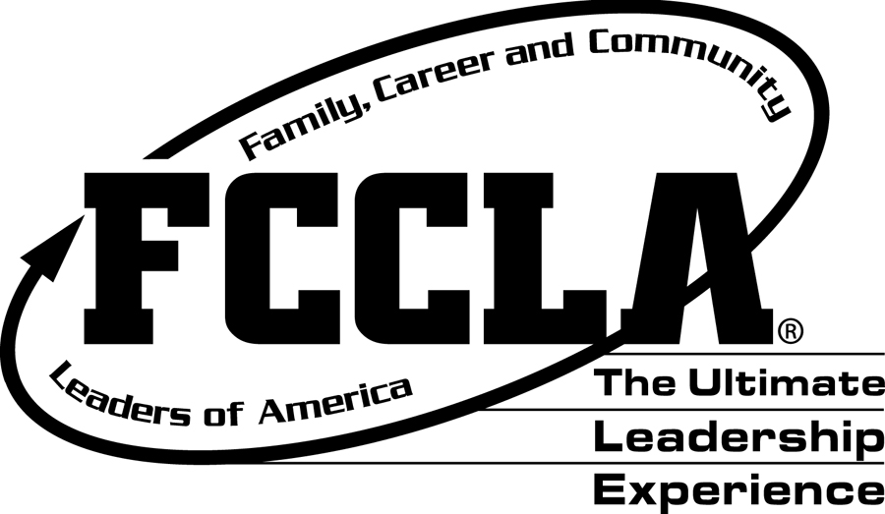
KANSAS FCCLA PEER EDUCATION SCHOLARSHIP APPLICATION DIRECTIONS
Please email a copy of your completed Scholarship Application to:
Shandi Andres at: sdandres@ksu.edu by February 20

ELIGIBILITY REQUIREMENTS:
The scholarship candidate:
- has been an active FCCLA member for three semesters
- has completed at least two semesters of Family and Consumer Sciences at the high school level
- has participated in a minimum of two school and community activities
- has a 3.0 GPA on a 4.0 scale
- is planning for a career of their choice
- has actively participated in national programs other than STAR events or Power of One

PROVISIONS FOR AWARDING SCHOLARSHIPS:
- The scholarship is available to graduating FCCLA members.
- Scholarship recipient must attend a two or four-year college or university in Kansas.
- Two scholarships of $200 each may be awarded each year.
- Applications must be mail to the Kansas FCCLA State Office
- Scholarships will be paid directly to the college or university after the Kansas FCCLA state office has received verification of enrollment from the scholarship recipient
- Recipients will be announced at the annual State Leadership Conference.

HIGH SCHOOL SENIORS should complete the entire application form and return it with a high school transcript with the counselor’s signature. On a separate paper, please list your FACS courses taken in high school and the length of time in which you took them. (One or two semesters) Scan & Email directly to Shandi Andres sdandres@ksu.edu

KANSAS FCCLA PEER EDUCATION
SCHOLARSHIP APPLICATION FORM

DO NOT ALTER THE FORMAT OF THIS APPLICATION
AND PLEASE TYPE EVERYTHING IN AN ARIAL 12-POINT FONT.

I. | Date of Application:
I. | Name of Applicant:
I. | Applicant Address:
I. | Parent’s Names:
I. | Parent’s Address:
I. | Total Semesters of FACS Courses Taken:
I. | Years as an FCCLA Member:
I. | Type of Chapter: (Occupational of Comprehensive)
II. | High School(s) Attended:
II. | High School(s) Address:
II. | Dates Attended:
II. | Graduation Date:
III. | Summarize your FCCLA Activities and specifically describe the national program activities to be considered for this scholarship.
IV. | Summarize your school activities other than FCCLA.
V. | Summarize your Family and Consumer Sciences activities and projects.
VI. | Summarize your community activities.
VII. | List high school scholastic honors. (Honorary Societies, etc.)
VIII. | List your work experience. Include your employers, type of work, and your dates of employment.
IX. | What college or university in Kansas do you plan to attend?
X. | Summarize in a paragraph why you feel you deserve this scholarship.
XI. | Explain the following:
XI. | Why do you plan to continue your education?
XI. | What will be your major area of study?
XI. | What are your plans upon completing your education?
XI. | How do your future plans include FCCLA?
XII. | Describe the leadership role you assume in your family.
XIII. | Include the following with your application form:
XIII. | Statement of recommendation from your Chapter Advisor or School Administrator.
XIII. | High School Transcript (must have a 3.0 GPA or above) with counselor’s signature.
XIV. | Signature of Applicant |  |  |  |  |  | Date:

Please email a copy of your completed Scholarship Application,
Transcript, and Statement of Recommendation to:
Shandi Andres at: sdandres@ksu.edu

Please send as 1 pdf if possible.

SCHOLARSHIP APPLICATION SCORE CARD
TO BE COMPLETED BY THE EVALUATION COMMITTEE

Name:________________________________________________
Address: ______________________________________________

CRITERIA | 5 | 4 | 3 | 2 | 1 | COMMENTS
FACS classes
FCCLA Activities - specifically national programs
School Activities
FACS Activities
Community Activities
Honors
Essay
Reasons for Continuing Education
Family Leadership Role
FCCLA Advisor/Administrator Recommendation
Transcript reflecting GPA
Major in College
Grammar/Spelling/Neatness

Comments:

