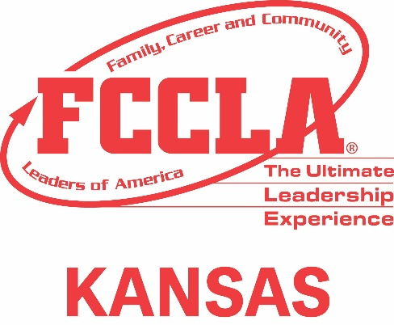
Where Leaders Take Root
2026-2027 State
Community Service

Project Recognition Form (due February 20 to sdandres@ksu.edu)
This year's community service theme, "Where Leaders Take Root," highlights the idea that leadership does not happen overnight. Just as a plant needs a pot for protection, soil, water, sunlight, and care to grow, leaders need support, guidance, and opportunities to develop.
Where Leaders Take Root is a community service project designed to promote compassion, awareness, and meaningful action by meeting needs within our local community.

Award Requirements:
Platinum- 50 or more hours among your chapter
Gold- 40- 49 hours of community Service among your chapter
Silver- 25-39 combined hours of Community Service among your chapter
Bronze- 15-24 combined hours of Community Service among your chapter

List of Community Service completed (may attach list) Project, Number of Hours
________________________________________________________________________________________________________________________________________________________________________________________________________________________________________________________________________________________________________________________________________________________________________________________________________________________________________________________________________________________________________________________________________________________________________________________________________________________________________________________________________________________________________________________________________________________________________________________________________________________________________________________________________________________________________________________

Chapter Name: ________________________________ Number of Members in your Chapter: _________
Chapter President Signature: ______________________ Adviser Signature: _______________________
Kansas FCCLA wants to thank you for your participation in this year's Community Service Project. Below fill in some quick information to have the opportunity to win an award and receive recognition. This Form is Due February 20th!

How to Calculate Time for Chapter & Community Rewards:
1. Track Each Member’s Time
For every project, record:
- Start time
- End time
- Total minutes spent working
(Example: 3:00 PM–4:30 PM = 90 minutes)

2. Convert Minutes to Hours
Divide total minutes by 60.
- 60 minutes = 1 hour
- 30 minutes = 0.5 hours
- 15 minutes = 0.25 hours
Example:
90 minutes ÷ 60 = 1.5 hours

3. Multiply Hours × Number of Members
For chapter totals, multiply the hours each project took by the number of participating members.
Example:
-8 members worked 1.5 hours
- 8 × 1.5 = 12 total chapter hours

4. Add All Project Hours Together
Once all project totals are calculated, add them up to determine your chapter’s combined community service hours.

If you have any questions email:
Kansas State Adviser: Shandi Andres - sdandres@ksu.edu

